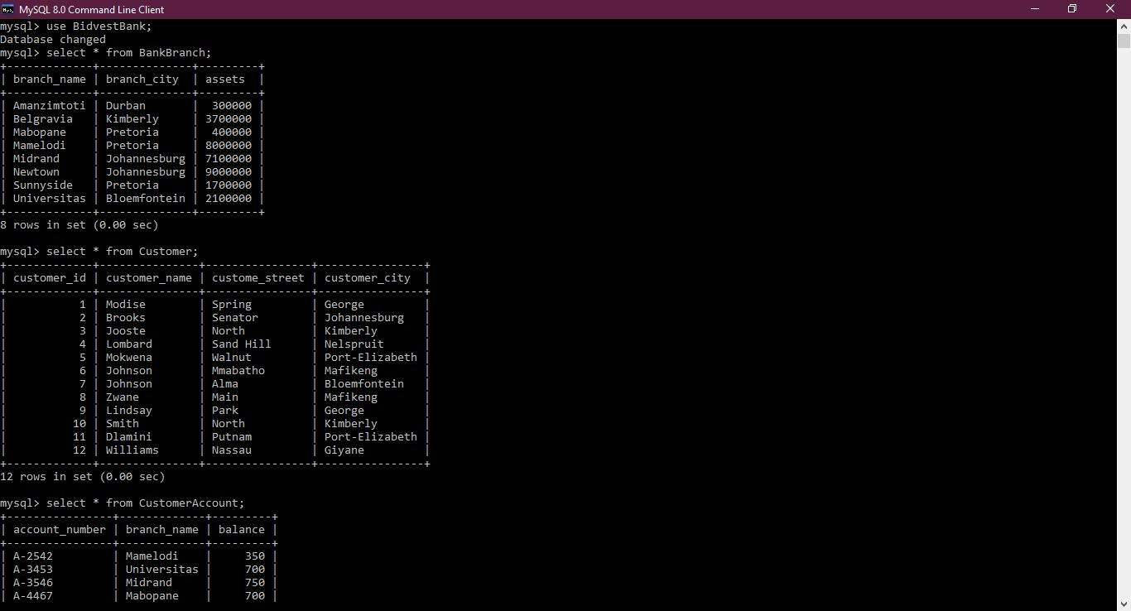

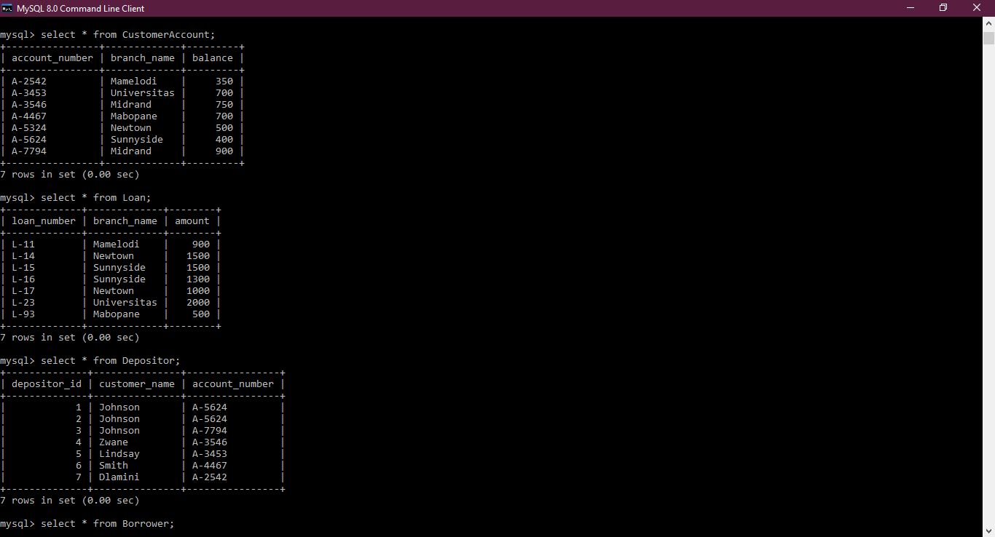

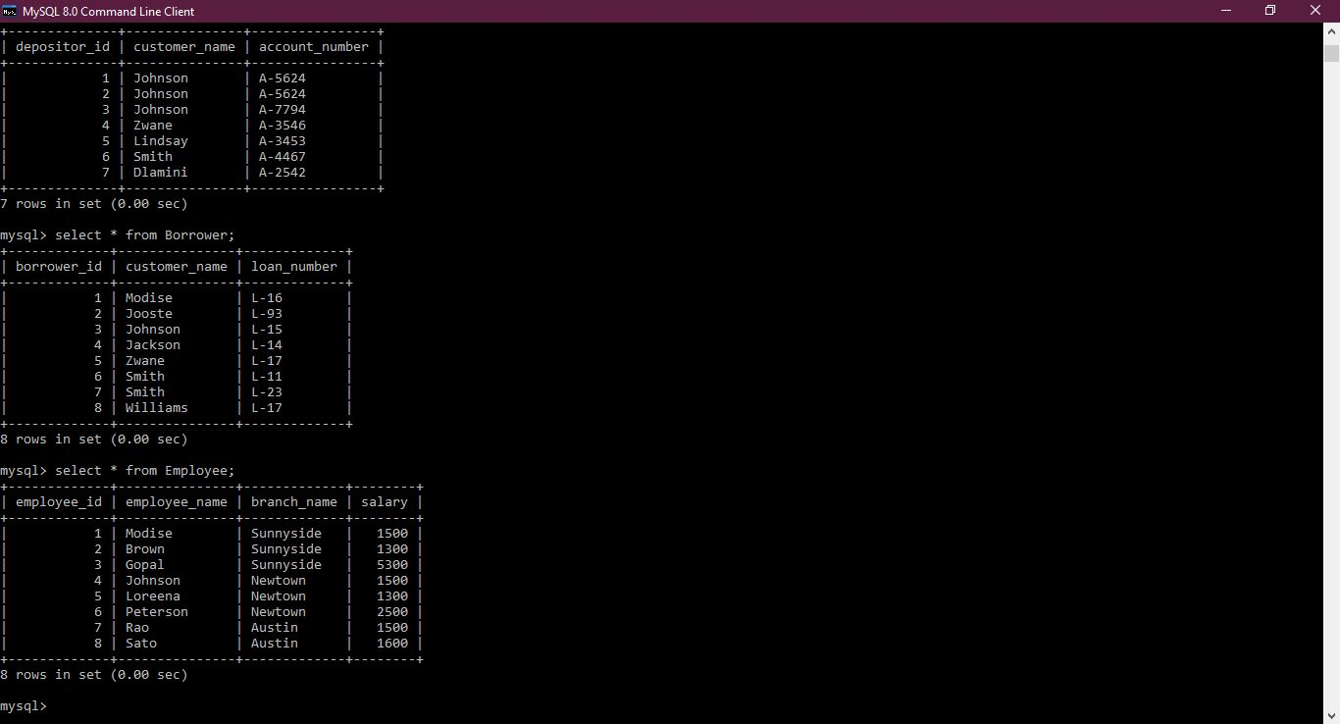

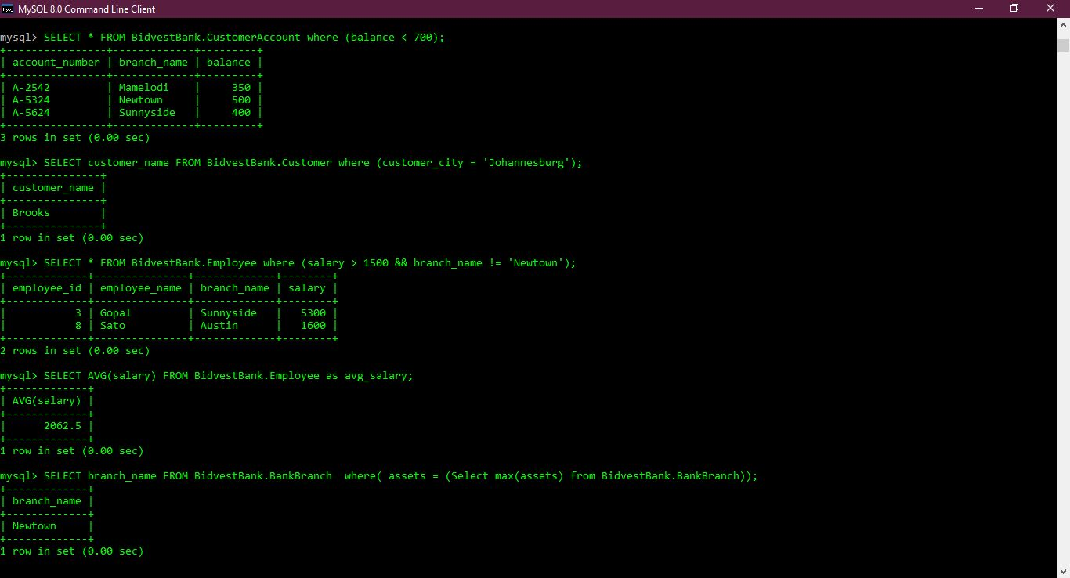

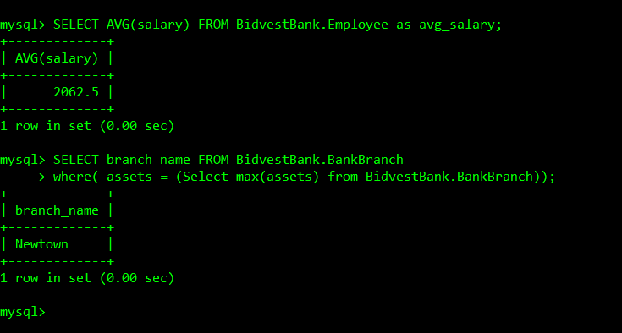

Question 5  
i. SELECT employee_name FROM bidvestbank.employee where(branch_name = 'Sunnyside');

ii. SELECT * FROM bidvestbank.borrower;

iii. SELECT account_number FROM bidvestbank.customeraccount where(balance > 900);

iv. SELECT account_number, balance FROM bidvestbank.customeraccount

where(branch_name = 'Newtown' && balance > 600);

v. SELECT branch_name, assets FROM bidvestbank.bankbranch;